SIMATS ENGINEERING (SAVEETHA SCHOOL OF ENGINEERING)
Department of Information Technology
CO2 ASSESSMENT TOOL 2 – Architecture Design Assignment

Course Code: | CSA1007 | Course Title: | Software Engineering
CO Assessed: | CO2 | Assessment: | Assessment Tool 2 – Architecture Design Assignment
Weightage: | 20% | Total Marks: | 25
CO2 Statement: | Perform detailed requirements analysis, design scalable architectures, and prioritize features with a focus on cross-disciplinary skills
Student Name: | Abarajithan S | Reg. No.: | 192521299
Date: | 07/08/2026 | Duration: | 60 minutes

Code of Conduct
I Abarajithan S/192521299 (Name / Reg No) certify that this submission is my original work and that I have adhered to the guidelines specified for this assessment. I understand that any violation of academic integrity rules will result in disciplinary action.
Signature of the Student: Abarajithan S
Annexure A – Architecture Design Assignment

Problem Statement: Intelligent Hospital Asset Tracking and Patient Flow Management Platform

1. Analyze System Requirements
1.1 System Overview and Objectives
The assigned problem statement focuses on developing an Intelligent Hospital Asset Tracking and Patient Flow Management Platform that enables hospitals to monitor medical equipment, manage patient movement, reduce waiting time, optimize resource utilization, and improve operational efficiency through real-time tracking technologies such as RFID and IoT.

Hospitals often experience delays due to misplaced medical equipment, inefficient patient movement between departments, overcrowding, and lack of real-time visibility into hospital resources. The proposed platform addresses these challenges by providing centralized monitoring, intelligent asset tracking, patient flow management, automated alerts, and analytical reports for hospital administrators.
The major objectives of the proposed system are:
- Track medical equipment such as wheelchairs, ventilators, infusion pumps, ECG machines, and portable monitors in real time.
- Monitor patient movement from registration to discharge across different hospital departments.
- Reduce patient waiting time by optimizing queues and appointment scheduling.
- Improve utilization of hospital assets and medical resources.
- Provide real-time alerts when equipment leaves authorized areas or requires maintenance.
- Generate operational reports for hospital administrators.
- Enhance patient safety and hospital service quality.
- Support secure role-based access for hospital staff.

1.2 Functional Requirements Influencing the Architecture

The following functional capabilities directly influence the selection and design of the software architecture.
- User Authentication and Role Management
- The system shall authenticate administrators, doctors, nurses, asset managers, and patients using secure login credentials. Each user is provided with role-based permissions to access only authorized system functions.
- Hospital Asset Tracking Module
- The platform continuously monitors the location of medical equipment using RFID tags and IoT sensors. Hospital staff can instantly locate available equipment through the centralized dashboard.
- Patient Flow Management Module
- The system records patient movement throughout the hospital, including registration, consultation, laboratory tests, pharmacy, admission, surgery, recovery, and discharge. This enables hospitals to identify bottlenecks and improve patient flow.
- Appointment and Queue Management
- Patients can schedule appointments online, while doctors and nurses monitor consultation queues. The system automatically updates queue status and estimated waiting time.
- Emergency Alert Service
- Whenever critical equipment becomes unavailable, leaves a designated location, or an emergency patient requires immediate attention, the platform automatically generates notifications to responsible hospital staff.
- Reporting and Analytics Module
- The system collects operational data from every module and generates reports related to equipment utilization, patient waiting time, department workload, emergency response performance, and hospital resource usage.

- Notification Service
- The platform sends notifications through SMS, email, or mobile applications regarding appointments, emergency alerts, equipment maintenance schedules, and patient status updates.
- Data Management Module
- All patient records, equipment details, appointment information, maintenance history, and hospital reports are securely stored within the centralized database for future retrieval and analysis.

1.3 Non-Functional Requirements and Quality Attributes

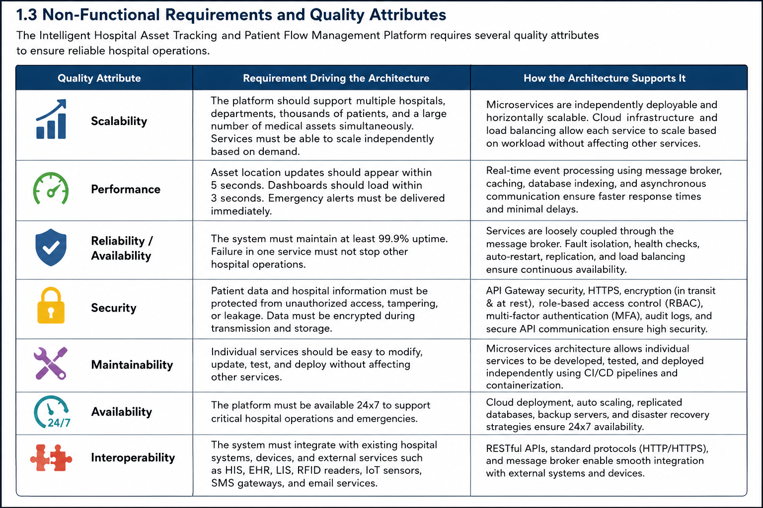

2. Select a Suitable Software Architecture

2.1 Selected Architecture: Cloud-Native Microservices with Event-Driven Communication
For the proposed Intelligent Hospital Asset Tracking and Patient Flow Management Platform, a Cloud-Native Microservices Architecture combined with an API Gateway and Event-Driven Communication is selected as the most appropriate architectural style.
Hospitals generate continuous real-time data from RFID readers, IoT sensors, patient registration systems, appointment systems, and emergency monitoring devices. Each functional module performs a different task and experiences different workloads. Therefore, separating each major function into an independent microservice provides better scalability, maintainability, reliability, and performance than a traditional monolithic system.

The proposed architecture consists of the following major components:
- Web Dashboard
- Mobile Application
- API Gateway
- Authentication Service
- Patient Flow Management Service
- Hospital Asset Tracking Service
- Appointment & Queue Management Service
- Notification Service
- Reporting & Analytics Service
- User Management Service
- Message Broker (Event Bus)
- Database Layer
- RFID Readers
- IoT Sensors
- Hospital Information System (HIS)
- Email/SMS Notification Gateway
The API Gateway acts as the single entry point for all client requests, while the Message Broker enables asynchronous communication between independent services.

2.2 Justification
The selected architecture satisfies all major system requirements identified during the analysis phase.

Independent Functional Modules
Hospital asset tracking, patient flow monitoring, emergency alerts, appointment management, reporting, and authentication perform different tasks. Microservices separate these modules so they can be developed, deployed, and maintained independently.

Independent Scalability
Patient registration and appointment services receive heavy traffic during hospital working hours, while reporting services are mainly used by administrators. Microservices allow only the heavily loaded services to scale without affecting the remaining modules.

Fault Isolation
If one service, such as the Reporting Service, becomes unavailable, the remaining services—including Patient Tracking, Asset Monitoring, and Emergency Alerts—continue operating normally. This improves hospital availability and reliability.

Real-Time Event Processing

RFID readers and IoT sensors continuously send equipment location updates. Using an Event-Driven Message Broker allows multiple services to receive these updates simultaneously without directly communicating with one another.

Security
The API Gateway authenticates every user before forwarding requests to internal services. Role-Based Access Control (RBAC), Multi-Factor Authentication (MFA), HTTPS communication, and encrypted databases improve overall security.

Easy Maintenance
Since every module is independently deployable, software updates, bug fixes, or feature additions can be completed without shutting down the entire hospital management platform.

Third-Party Integration
The architecture easily integrates with external systems such as:
- Hospital Information System (HIS)
- Electronic Health Record (EHR)
- Laboratory Information System (LIS)
- Pharmacy Management System
- RFID Readers
- IoT Devices
- SMS Gateway
- Email Gateway
3. Software Architecture Diagram
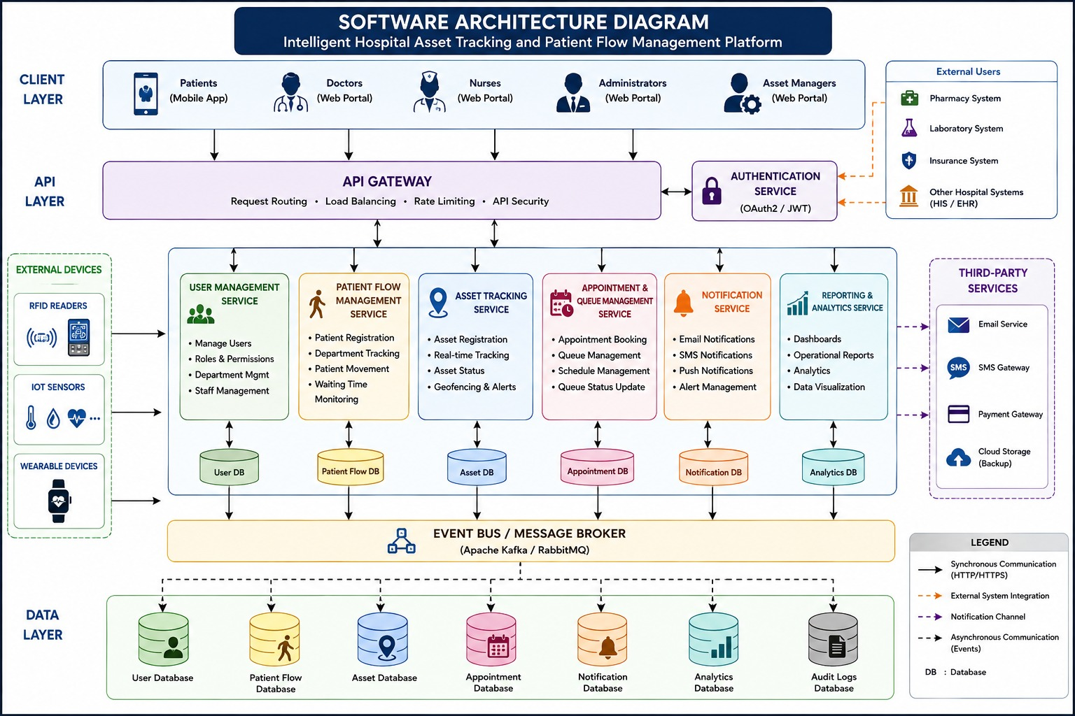

4. Explain Components and Their Interactions

4.1 Component Responsibilities

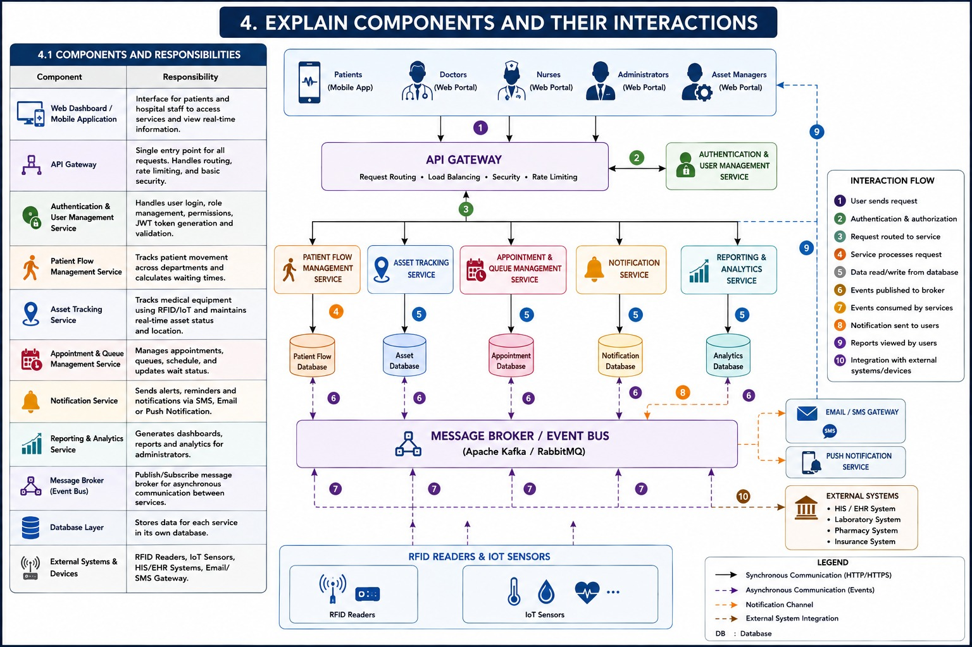

4.2 Communication and Workflow
The communication among system components follows a secure and scalable workflow.
- Hospital users access the platform using the Web Dashboard or Mobile Application.
- The request is sent to the API Gateway.
- The API Gateway authenticates the user through the Authentication Service.
- After successful authentication, the request is forwarded to the appropriate microservice.
- RFID Readers continuously monitor the location of medical equipment and transmit location updates.
- IoT Sensors collect equipment status and environmental information.
- The Asset Tracking Service processes equipment location updates and stores them in the Asset Database.
- The Patient Flow Management Service records patient movement throughout different hospital departments.
- Appointment and Queue Management Service updates patient appointments and consultation queues.
- The Message Broker distributes real-time events to the Reporting Service, Notification Service, and Analytics Service.
- The Notification Service immediately sends alerts whenever emergency situations or equipment shortages occur.
- The Reporting Service collects data from all services and generates dashboards and operational reports for hospital administrators.
The Event-Driven communication model enables each microservice to operate independently, ensuring faster response times and improved system reliability.

5. Discuss Quality Attributes

5.1 Scalability
The proposed Microservices Architecture allows every service to scale independently according to its workload.
For example, during peak hospital hours, the Appointment Management Service and Patient Flow Management Service can be allocated additional computing resources without affecting the Reporting Service or Notification Service.
Similarly, if multiple hospital branches are connected to the platform, new microservice instances can be deployed without redesigning the existing architecture.

5.2 Security
Security is one of the most important quality attributes because the platform handles confidential patient information.
The proposed architecture ensures security through:
- Secure User Authentication
- Role-Based Access Control (RBAC)
- Multi-Factor Authentication (MFA)
- HTTPS Communication
- Data Encryption (At Rest & In Transit)
- Secure API Communication
- Audit Logs
- Regular Database Backup
These security mechanisms ensure that only authorized users can access patient information and hospital resources.

5.3 Performance
The platform is designed to process hospital operations with minimum delay.
Performance improvements include:
- Real-time RFID asset tracking
- Fast patient queue updates
- Dashboard loading within a few seconds
- Immediate emergency notifications
- High-speed report generation
- Database indexing for faster queries
- Caching of frequently accessed information
The Event-Driven communication mechanism reduces unnecessary communication between services, improving response time.

5.4 Reliability
Reliability ensures uninterrupted healthcare services even if one component fails.
The architecture provides reliability through:
- Independent Microservices
- Fault Isolation
- Automatic Service Restart
- Message Queue Retry Mechanism
- Database Replication
- Continuous Monitoring
- Health Checks
If one service becomes unavailable, the remaining services continue operating normally.

5.5 Maintainability
The proposed architecture is highly maintainable because each module performs a specific responsibility.
Benefits include:
- Independent Module Development
- Easy Bug Fixing
- Independent Deployment
- Reusable Components
- Simple Testing
- Faster Software Updates
- Easier Future Enhancements
This significantly reduces maintenance cost and downtime.

5.6 Availability
Hospitals require uninterrupted system availability throughout the day.
The proposed platform achieves high availability through:
- 24×7 Cloud Deployment
- Load Balancing
- Multiple Service Instances
- Database Replication
- Automatic Failover
- Backup Servers
- Continuous Monitoring
These techniques ensure that the platform remains available even during hardware failures or maintenance activities.

6. Justify Architectural Decisions

6.1 Rationale
The proposed Cloud-Native Microservices Architecture with Event-Driven Communication was selected because it effectively addresses the functional and non-functional requirements of the Intelligent Hospital Asset Tracking and Patient Flow Management Platform.
Hospitals continuously generate large volumes of real-time data from patient registrations, RFID asset tracking devices, IoT sensors, appointment systems, and emergency services. These workloads have different processing requirements and cannot be efficiently managed using a traditional monolithic architecture.
By dividing the application into independent microservices, each hospital function can be developed, deployed, maintained, and scaled independently without affecting other services.
The API Gateway provides a secure entry point for all client requests, while the Event-Driven Message Broker enables efficient communication between services without creating tight dependencies.
This architecture supports real-time monitoring, secure communication, high availability, and future expansion of hospital services.

6.2 Trade-offs Considered
Although the selected architecture provides many advantages, several trade-offs were considered during the architectural decision-making process.

Operational Complexity
A Microservices Architecture contains multiple independent services that require container management, service discovery, monitoring, logging, and orchestration.
Although this increases deployment complexity, the advantages of modularity, scalability, and fault isolation outweigh the additional operational effort.

Distributed Communication
Since services communicate over secure REST APIs and the Message Broker, network communication introduces slight latency compared to direct function calls inside a monolithic application.
However, asynchronous communication improves overall system responsiveness and reduces service dependency.

Data Consistency
Each microservice manages its own database.Because information is exchanged asynchronously, temporary delays in data synchronization may occur.This is acceptable because hospital asset tracking and patient monitoring prioritize continuous availability over immediate database consistency.

Infrastructure Cost
Deploying multiple microservices, API Gateway, Message Broker, cloud servers, monitoring tools, and replicated databases requires greater infrastructure investment than a monolithic system.
However, hospitals benefit from:
- Better reliability
- Lower downtime
- Independent scalability
- Easier maintenance
- Improved patient care
making the investment worthwhile.

6.3 Support for Future Enhancements and Long-Term Maintainability
The proposed architecture has been designed to support future technological advancements without requiring major redesign.
Possible future enhancements include:
- Artificial Intelligence for predicting patient waiting time.
- Machine Learning models for predicting equipment failures.
- Integration with Electronic Health Records (EHR).
- Smart Bed Management System.
- Ambulance Tracking System.
- Telemedicine Integration.
- Facial Recognition for Patient Identification.
- Mobile Application for Doctors and Nurses.
- Voice Assistant for Hospital Staff.
- Cloud-Based Multi-Hospital Management.
- Wearable Healthcare Device Integration.
- Predictive Analytics Dashboard for Hospital Administrators.
Since every module is developed as an independent microservice, new services can be added without interrupting existing hospital operations.The modular architecture also simplifies software testing, deployment, debugging, and future maintenance.Overall, the proposed architecture ensures long-term scalability, maintainability, reliability, and flexibility while supporting future digital transformation initiatives in healthcare.

7. Conclusion
The Intelligent Hospital Asset Tracking and Patient Flow Management Platform was analyzed to identify its functional requirements, non-functional requirements, and critical quality attributes.Based on the system requirements, a Cloud-Native Microservices Architecture with Event-Driven Communication was selected as the most suitable architectural style because it provides modularity, scalability, security, reliability, maintainability, and high availability.The architecture includes independent microservices for patient flow management, hospital asset tracking, appointment scheduling, user authentication, notification services, reporting, and analytics. These services communicate securely through an API Gateway and an Event-Driven Message Broker while integrating with RFID readers, IoT sensors, Hospital Information Systems (HIS), and external notification gateways.The proposed architecture ensures efficient hospital operations by enabling real-time asset tracking, reducing patient waiting time, improving equipment utilization, and supporting timely emergency response. It also supports future enhancements such as Artificial Intelligence, Machine Learning, predictive analytics, telemedicine, wearable device integration, and multi-hospital cloud deployment.In conclusion, the proposed architecture provides a robust, scalable, secure, and maintainable foundation requirements and adapting to future technological advancements.

